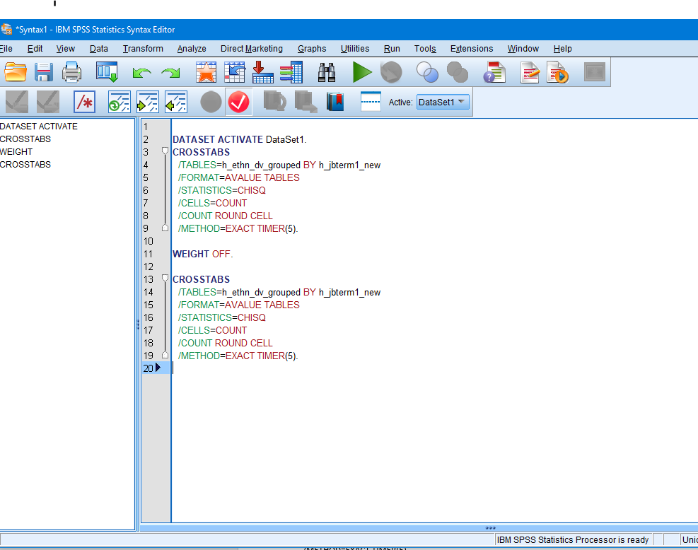
Second SYNTAX WEIGHT off
First SYNTAX WEIGHT ON

First Syntax Weight on: (Weighted by h_inpxui_xw) (using SPSS function DATA > WEIGHT CASES )
Output :

Chi-Square Tests
 | Value | df | Asymptotic Significance (2-sided) | Exact Sig. (2-sided) | Exact Sig. (1-sided) | Point Probability
Pearson Chi-Square | .821ª | 2 | .663 | .690
Likelihood Ratio | .713 | 2 | .700 | .690
Fisher's Exact Test | 1.141 |  |  | .631
Linear-by-Linear Association | .384^{b} | 1 | .535 | .598 | .285 | .042
N of Valid Cases | 1015
a. 2 cells (33.3%) have expected count less than 5. The minimum expected count is 1.86.
b. The standardized statistic is .620.

Second Syntax Weight OFF

Chi-Square Tests
 | Value | df | Asymptotic Significance (2-sided) | Exact Sig. (2-sided) | Exact Sig. (1-sided) | Point Probability
Pearson Chi-Square | 7.751ª | 2 | .021 | .020
Likelihood Ratio | 6.483 | 2 | .039 | .043
Fisher's Exact Test | 7.291 |  |  | .027
Linear-by-Linear Association | 7.589^{b} | 1 | .006 | .006 | .006 | .001
N of Valid Cases | 962
a. 1 cells (16.7%) have expected count less than 5. The minimum expected count is 4.93.
b. The standardized statistic is 2.755.

